# Understanding Kalman Filters

# Why Use Kalman Filters? | Understanding Kalman Filters

视频共7节

[Why Use Kalman Filters? | Understanding Kalman Filters, Part 1 - YouTube](https://www.youtube.com/watch?v=mwn8xhgNpFY&list=PLn8PRpmsu08pzi6EMiYnR-076Mh-q3tWr)

博客

[卡尔曼滤波 | Welcome to Zjl's Blog (zjlzjl.com)](https://zjlzjl.com/2021/01/12/%E5%8D%A1%E5%B0%94%E6%9B%BC%E6%BB%A4%E6%B3%A2/)

**Programming Drones with Simulink**

[Programming Drones with Simulink Video - MATLAB & Simulink (mathworks.cn)](https://ww2.mathworks.cn/videos/programming-drones-with-simulink-1513024653640.html?s_eid=PSM_15028)

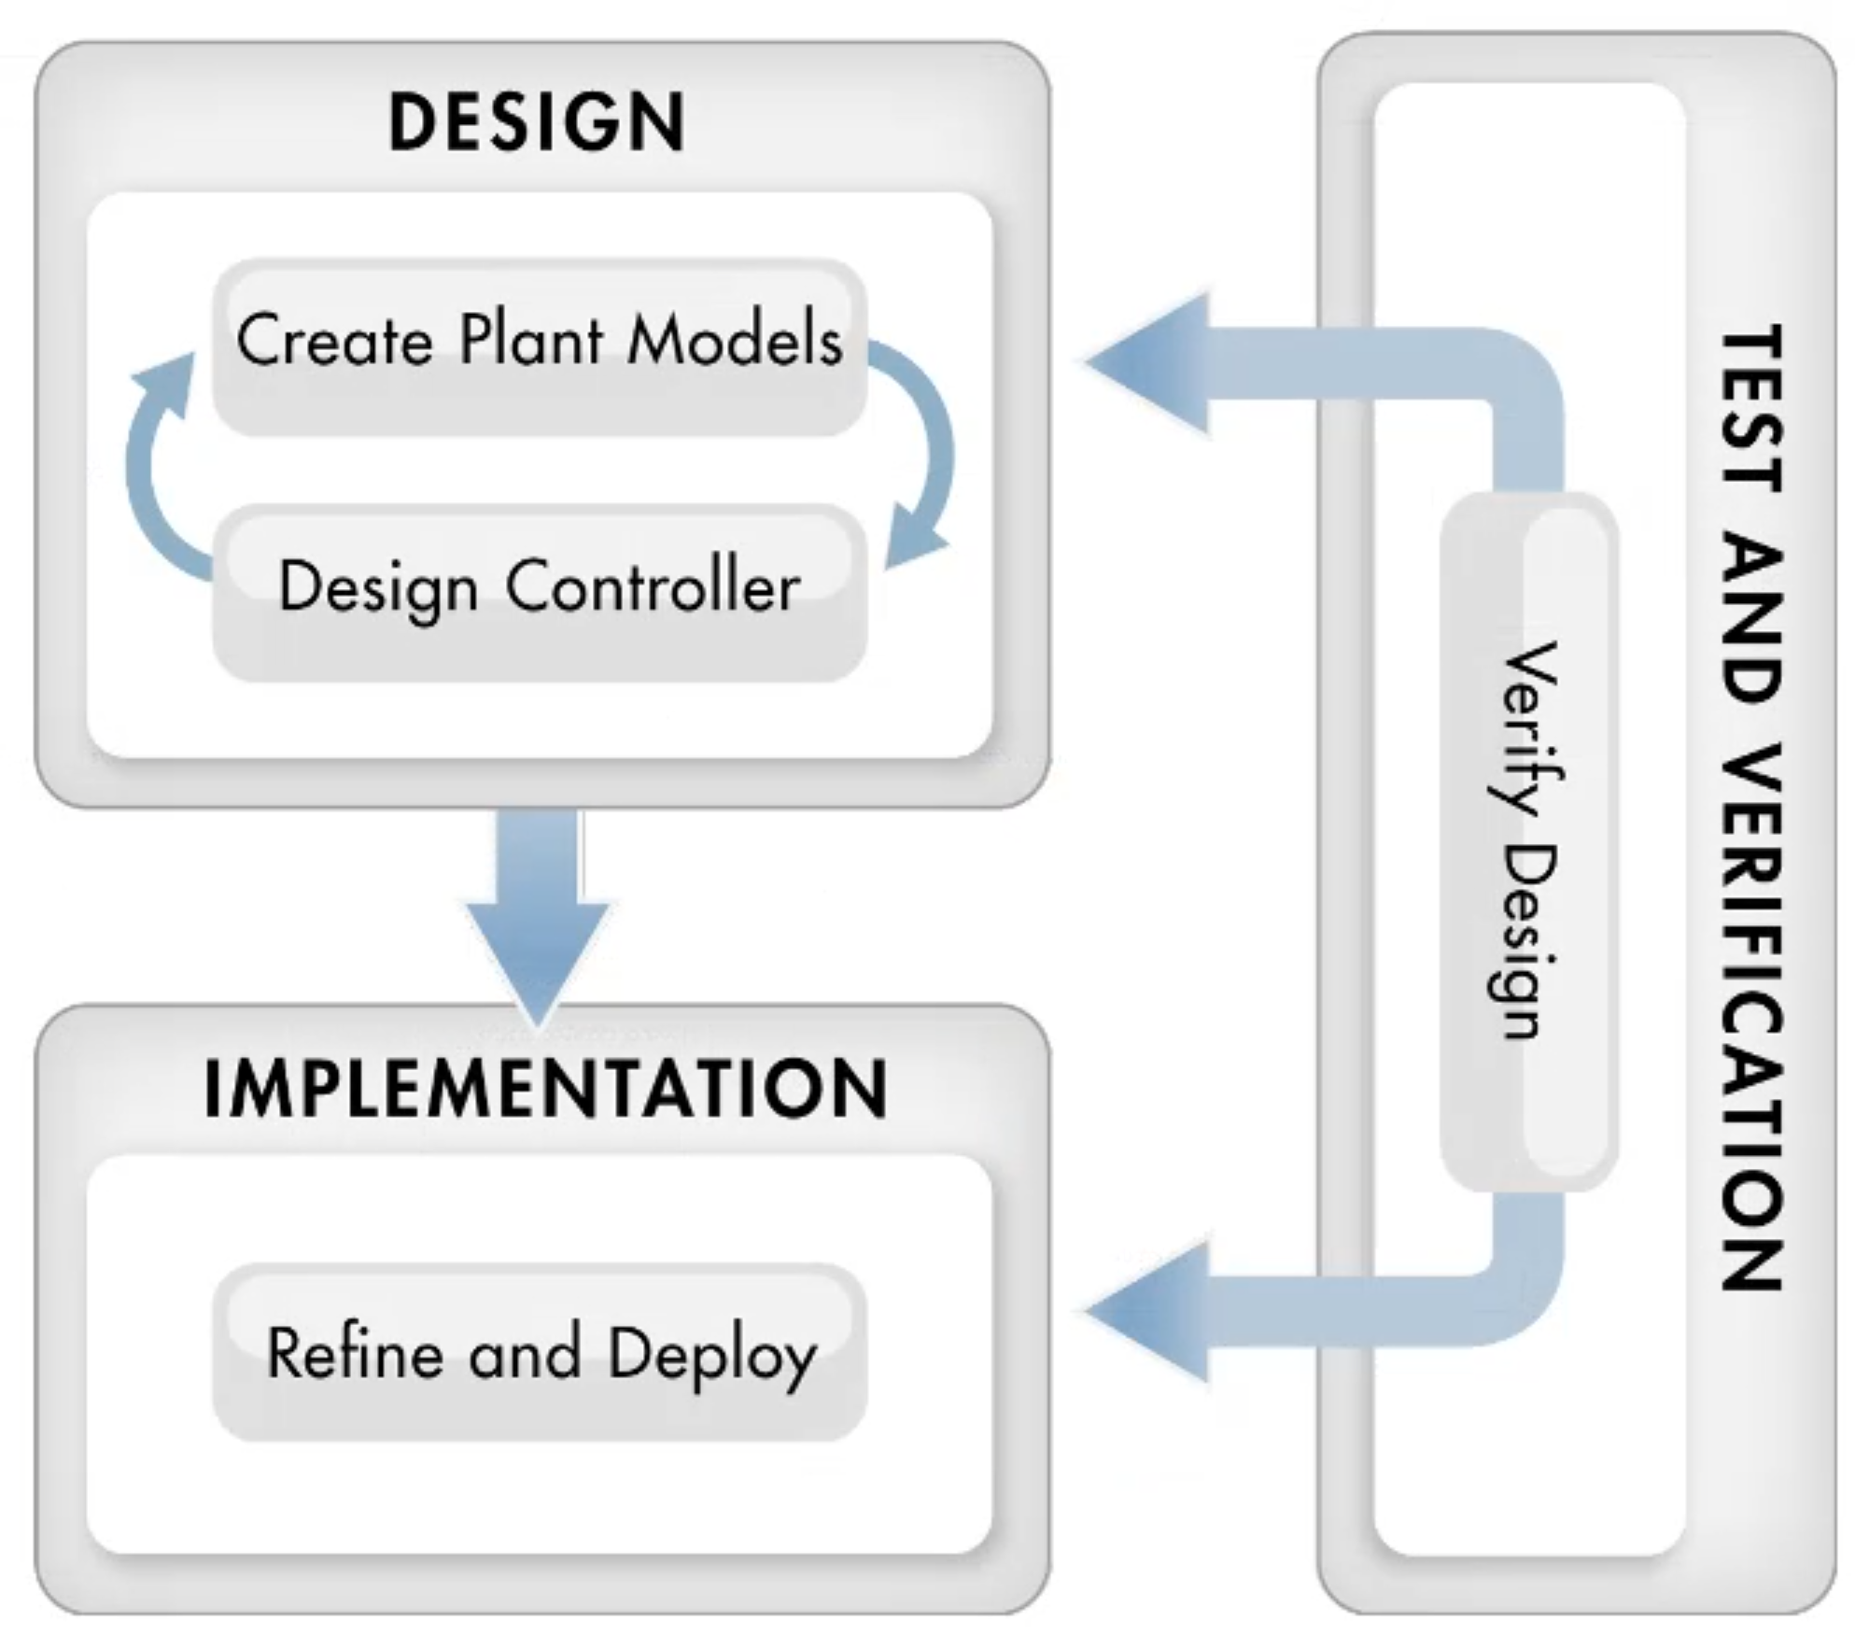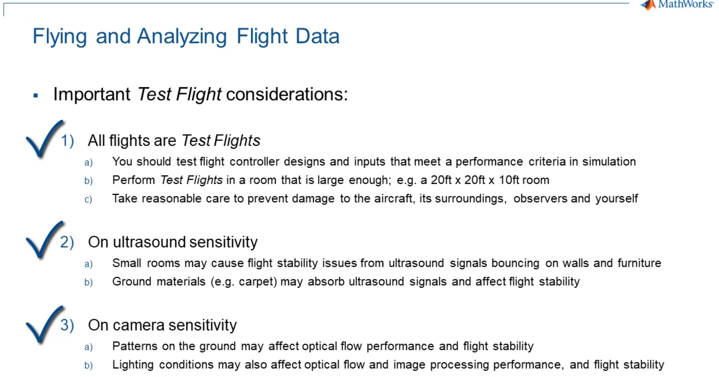

参考Github案例和博客

[sundexin111/asbQuadcopter: 无人机仿真，主要针对姿态解算和控制两个模块 (github.com)](https://github.com/sundexin111/asbQuadcopter)

[四旋翼飞行器建模及控制 | Welcome to Zjl's Blog (zjlzjl.com)](https://zjlzjl.com/2021/01/10/%E5%9B%9B%E6%97%8B%E7%BF%BC%E6%8E%A7%E5%88%B6/)

# Why Use Kalman Filters? | Understanding Kalman Filters

视频共7节

[Why Use Kalman Filters? | Understanding Kalman Filters, Part 1 - YouTube](https://www.youtube.com/watch?v=mwn8xhgNpFY&list=PLn8PRpmsu08pzi6EMiYnR-076Mh-q3tWr)

大纲如下：

